*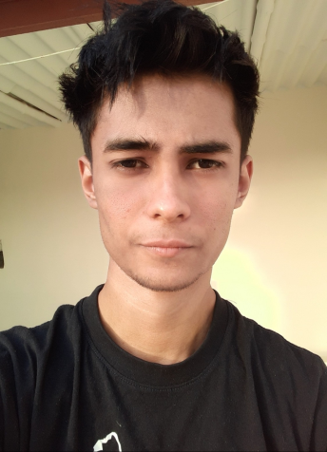SYED MUHAMMAD ASHAR SAGHIR*

MERN STACK DEV

**LinkedIn:**

**GitHub:** https://github.com/syedashar1

**Personal Site :** https://................

**Email:** [saghirashar@gmail.com](mailto:hamzashahab1610@gmail.com)

**Contact:** +92 335217310 whatsApp only

## CAREER OBJECTIVE

A MERN stack web developer with 3.5 years’ work experience, along with good communication skills and possessing the ability to work brilliantly in team.

Currently working as independent Freelance Developer only.

# EXPERIENCE

### MARCH 27TH, 2020 – MAY 29TH, 2020

**FULL STACK WEB DEVELOPER,** ZENVEUS

Worked as a part-time full-stack web developer Served as a team lead on some projects

Managed projects based on ReactJS , REDUX and NodeJS (MERN Stack)

### FEBRUARY 17TH – APRIL 15TH, 2020

**WEB DEVELOPER, NEUROCOMPUTATION LAB,** NCAI | NEDUET

Maintaining the backend and databases of the lab’s research projects

Designing the front end of the projects plus regular refactoring of the code-base and

### January 11 - 21 April , 2020

**WEB DEVELOPER (as a Team of 5) ,** Digitexa

Hired by Digitexa a turkish software house for a side project , for REDUX based ecommerce web app , basically my role was as a frontend state manager .

**23 December - 28 Febuary 2021**

**WEB DEVELOPER (independent) ,** Digitexa

Hired by Digitexa a turkish software house for a side project ,for a web chat application built on MERN , the theme of the project was to build an end to end encrypted chat app

That uses IDs instead of phone numbers.

**PROJECTS**

**Coolgram**

My take on instagram of 2017 , extensively built on **MERN , REDUX , FireBase** and socket.io Containing **all the features of instagram** and few more features like daily profile visits , distance locator through maps and more.

<https://github.com/syedashar1/Coolgram>

**Framily**

A family socializing App for an **Australian Company**. Inspired by Tinder and Facebook.

Built for a family instead of a single user.

<https://github.com/syedashar1/framily>

**Amazona**

A multi-vendor ecomerce websites with **4 different payment gateways and customer support by React and socket.io** for a Turkish software House.

<https://github.com/syedashar1/Amazon-Clone->

**CoverTalk**

Web Application that **works like WhatsApp** that uses random IDs to connect built for a Turkish software House.

<https://github.com/syedashar1/Master-Chat>

**Socio Gram**

A socializing web app **inspired by instagram** built for a **Canadian client**.

(Source code not permitted to post)

**Video Call Room web app**

A zoom clone built on React / socket.io / Peerjs / WebRTC

<https://github.com/syedashar1/Video-Call-Web-App>

**HangMan**

My project for university , built on **pure vanilla JavaScript** !

<https://github.com/syedashar1/vanillajs-hangman>

For more updated projects visit my github :

<https://github.com/syedashar1?tab=repositories>

# SKILLS

# 3 years of experience in:

* React Js
* REDUX
* Node Js / Express Js
* Mongo DB
* FireBase
* WebSockets / socket.io
* Django (1 year experience only)
* Structure Design
* Git
* UX/UI designing (5 years’ experience)

# ACTIVITIES

* Member of the **GitHub Archive Program** (Arctic code vault contributor)
* Have contributed to various open source projects
* Runner up in **SENTEC Virtual Quiz Competition, 2020**
* Attended **GOOGLE DevFest 2019** at **IBA City Campus**, Karachi
* Participated in **Speed Programming** in **AKSC, 2019 | UIT**
* Participated in **Speed Programming** in **SuperCom, 2019 | Bahria University**
* Participated in **Speed Programming** in **SMEC, 2019 | SSUET**
* Participated in **Speed Programming** in **PROCOM, 2019 | FAST-NUCES**
* Participated in **Speed Programming** in **MPERC, SENTEC, 2019 | NEDUET**

# SOCIAL WORK

### Deputy Director of Team Graphics Design at ACM NEDUET Student Chapter

* **Member** of **Team Web Design and Development, AI Club**
* Member of **Team Graphics** at **SENTEC**, NED

# Hobbies

### Audiobooks

### Workout / Meditation and Gratitude exercises

### Collecting Fragrances